Module 1: Managing the Company to Meet Stakeholder Needs 1
Lesson 3: Risk, Return, and Risk Management 2
Learning Objectives 2
Risk and Return 3
Required Return 7
Types of Risk 10
The Control Function 22
Addressing Risk 27
The Three Lines of Defense 32

Module 1: Managing the Company to Meet Stakeholder Needs
An insurer’s overall direction is determined by its executives, with guidance from the board of directors. In this module, we explore how an insurer is organized and managed to balance the needs of a diverse set of stakeholder groups, and how an insurer manages the risk it must take in order to earn a return.
In this module, you’ll learn about
- How an insurer’s board and executives manage the company ethically to meet the needs of various stakeholders
- The ways an insurer can be organized for success
- How an insurer manages the various risks it faces to earn an appropriate return

Lesson 3: Risk, Return, and Risk Management
To continue in business, a company needs to earn a return. That is, it needs to make money. To make money, a company has to face the risk of losing money. Risk can’t be avoided, but it can be managed. Learn about the role of risk management in an insurer’s operations.

Learning Objectives

- Define risk and return, and explain the risk-return tradeoff.
- Determine an investment's required return using the risk-free rate of return and the risk premium.
- Describe and classify risks faced by insurance companies.
- Explain control and the control cycle.
- Describe techniques for managing risk, including risk transfer, diversification, and risk hedging.
- Explain enterprise risk management in financial services companies.
- Describe the three lines of defense, and explain how insurers use them to manage risk.

Risk and Return
Learning Objective
Define risk and return, and explain the risk-return tradeoff.
An insurer faces risk in virtually everything it does: selling a policy, hiring an employee, and generating profit. Taking a certain amount of risk is necessary for any company.
But companies have systems to identify and manage risks. These systems protect companies as much as possible while allowing them to pursue their goals and objectives.
Managing risk and return is the ultimate balancing act. Taking too much risk leaves a company vulnerable to financial loss. On the other hand, playing it too safe limits potential returns.
In this lesson, we explore the risk and return relationship. We'll see the risks that insurance companies face and what approaches they can use to manage them.
What's an Investment?
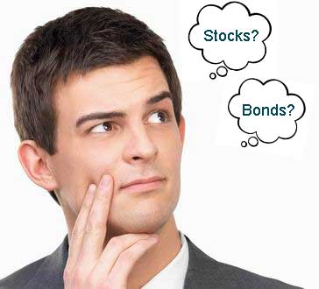
When you hear the word "investment," you probably think of stocks, bonds, and mutual funds. In business, stocks and bonds are assets, and purchasing stocks and bonds is a form of investing.
There are many other types of investments, though.

- Which actions below would be investments for Forthright Financial? Choose all that apply.
- Buying a stock or bond
- Launching a new product
- Hiring an employee
- Issuing a policy
- Opening a branch office
- Installing a new information system
- Acquiring a line of business from a competitor
All is correct!
Investment (Any use of resources that is intended to generate a profit or positive return.) is any use of resources with the aim of earning a profit. Issuing a policy is an investment for an insurer. Hiring an employee or installing a new information system may not seem to you like an investment, but Forthright cannot earn a profit without a quality work force or adequate information systems. So they ARE investments.

- Which of the investments in the previous question involves risk?
- None of these
- Some of these
- All of these

All of these
All of these! What do we mean by risk, though?

Risk
Risk (The possibility that an investment or other venture might have an unexpected result.) is the possibility of an unexpected result.
- A stock you buy could lose value
- An employee you hire might perform poorly
An investor expects an investment to earn a gain…a profit…a return (The reward, profit, or compensation an investor hopes to earn in exchange for taking a risk.).
Whatever you call it, an investor expects to earn some compensation for taking a risk.

What type of unexpected outcome can an investment have? Choose all that apply.
Which of these most likely best represents Forthright's approach to risk and return as regards its assets?
Risk-Return Tradeoff
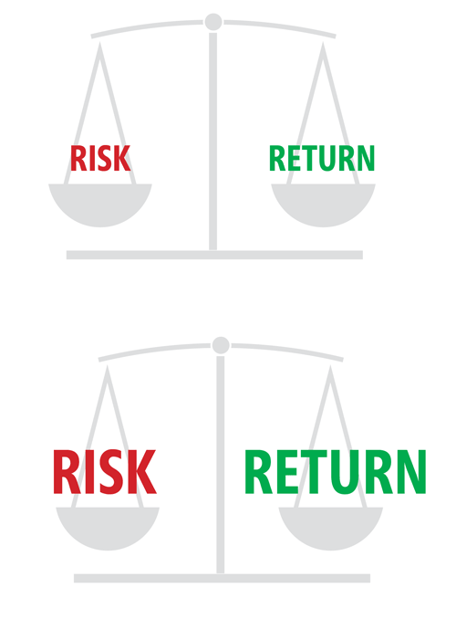
Whenever you find an opportunity for a return, you find risk. The relationship between risk and return is called the risk-return tradeoff (The relationship between risk and return that affects virtually all business transactions. In general, all other factors being equal, the greater the risk associated with an investment, the greater the expected return. The lower the risk associated with an investment, the lower the expected return.).
In general, the riskier an investment, the greater the potential return on the investment. Conversely, the less risky an investment, the lower the expected return.
- Earning an adequate return requires taking some amount of risk.
- Earning a huge return requires taking a huge risk.
- Where there's only a small risk, there's only a small potential return.
- Where there's a large risk, there's a large potential return.


- Which of the following statements is true about risk and/or return in an insurance company? More than one response may be correct.
- The risks insurance companies face are limited to the risks inherent in investing in securities, such as stocks and bonds.
- According to the concept known as the risk-return tradeoff, in order to earn a large return, an insurer must generally accept a large risk.

According to the concept known as the risk-return tradeoff, in order to earn a large return, an insurer must generally accept a large risk.
According to concept of the risk-return tradeoff, an insurer must take on a large amount of risk in order to earn a large return. Conversely, if the insurer only accepts a small amount of risk, it can generally only expect a small return.
However, the risks insurance companies face are NOT limited to the risk of investing in securities. The term "investment" refers to any use of resources with the aim of earning a profit, including but not by any means limited to investing in securities, and all these investments are subject to risk.

Required Return

Learning Objective
Determine an investment's required return using the risk-free rate of return and the risk premium.

Elements of a Required Return
A return from any source can be expressed in terms of a rate of return (The earnings on an investment expressed as a percentage of the principal. )—a percentage of the amount invested (called the principal).

Generally, an investor's required return (The return an investor needs to earn in order to make the investment, given the risk of the investment; typically found by adding the risk-free rate of return to the risk premium. )—the rate of return the investor needs to earn in order to make an investment—equals the sum of a risk-free rate (The return on a risk-free investment—the least risky investment opportunity available. See required return and risk premium.) and a risk premium (The component of investment return that compensates the investor for taking on the risk associated with a specific investment; the rate of return required in addition to the risk-free rate for the investor to make the investment.).

Risk-Free Rate + Risk Premium = Required Return

An investor expects to earn some compensation even when an investment is risk-free. The amount an investor expects to earn from a risk-free investment is called the risk-free rate.

Examples of risk-free rates include

The interest rate guaranteed on a Treasury bill
The interest rate on a savings bond
The interest rate on a bank certificate of deposit
The crediting rate guaranteed on a fixed annuity
For taking risk, an investor expects to earn an added return in addition to the risk-free rate. This added return, known as the risk premium, should be appropriate for the level of risk presented by the investment.

The required return on a risky investment is the total of the risk-free rate and the risk premium. Use the right arrows below to learn more.

Let's calculate Forthright's required return for a top-rated corporate bond.
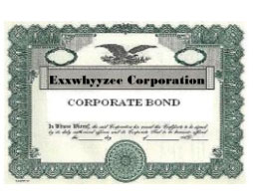
3% Risk-Free Rate
Forthright expects to earn at least a 3% return on its investment.

3% Risk-Free Rate
3.5% Risk Premium
For this bond, Forthright requires a 3.5% rate of return in addition to the risk-free rate for the bond.

3% Risk-Free Rate
3.5% Risk Premium
____________________________________
6.5% Required Return
Forthright's required return on this top-rated corporate bond is 6.5%.

You have the following information about an investment project:
The risk-free rate in the current market is 2 percent.
The investment project is moderately risky.
Your required return is 5 percent.
In this situation, the risk premium equals
- 3%
- 5%
- 10%
- 12%
quals
3%
The risk premium is the difference between the required rate of return (5 percent) and the risk-free rate of return (2 percent).
Risk premium = 5% – 2% = 3%

Types of Risk
Learning Objective
Describe and classify risks faced by insurance companies.
Question: How many risks do insurers face?
Answer: A lot!
Many people think that the only risk insurers face is the risk of insureds dying prematurely. Nothing could be further from the truth.
Different activities expose insurers to different types of risk. For example, an insurer encounters the risk of lower-than-expected returns when it invests in certain assets. Or let's say the company introduces a new product: it faces risks like lower-than-anticipated sales and higher-than-expected claims payments.
Let's look more closely at the different risks insurers must effectively manage.
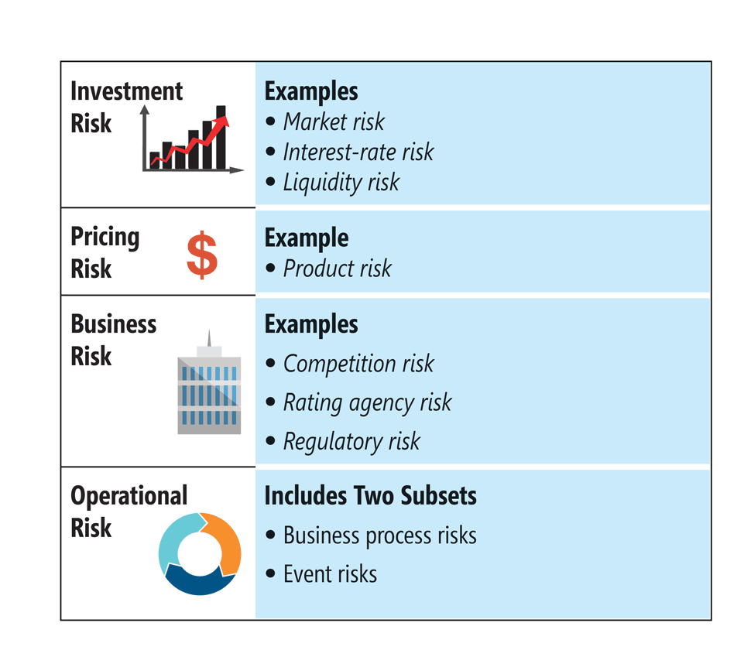
Investment Risk
Forthright uses funds collected from customers to buy assets like bonds. Investing exposes the investor to a number of investment risks. Click or touch each heading below to learn more.
Market Risk
Market risk (A risk of unexpected outcomes due to fluctuations in the market values in a given financial market. Also known as financial market risk.) is the chance of unexpected movements in the value of an entire market for assets, such as the stock market, bond market, currency markets, or real estate market.
Example
The stock market plummets or skyrockets.

Interest-Rate Risk
Interest-rate risk (The risk that unpredictable movements or stagnation in market interest rates will cause assets to lose value or liabilities to gain value.) is the risk that unpredictable movements or stagnation in market interest rates will cause assets to lose value or liabilities to gain value.
Example
Market interest rates remain low, making it difficult for Forthright to purchase new assets that will produce the necessary return on investment.

Default Risk
Default risk (The risk that a borrower will fail to pay its obligations. Also known as credit risk.) is the risk that a borrower—like a bond issuer or a mortgage owner—will fail to repay their debt.
Example
Forthright buys corporate bonds and the issuer fails to pay interest or pay back the borrowed amount.

Liquidity Risk
Liquidity risk (The risk of being unable to readily convert an asset to cash for its underlying value.) is the risk of being unable to quickly convert an asset to cash for its underlying value.
Example
Forthright needs cash to pay benefits to customers, but it can't quickly sell a shopping mall for its true value.

Pricing Risk
When designing a product, Forthright must determine how much to charge customers so that the product is both affordable and profitable. This process, known as pricing, is a source of pricing risk.
Pricing a product requires an insurer to make assumptions. For example, an insurer must estimate future mortality rates to determine how many claims the insurer is likely to pay each year.

Pricing risk is the risk that actual results do not match the insurer's assumptions. What are some sample pricing risks?
- A product might not sell well or might sell better than expected (also known as product risk).
- A product's charges might not cover the costs of marketing and administering the product.
- More people might surrender their policies or other contracts earlier than expected, or might exercise other contractual rights that are unfavorable to the issuing company.
- Life insurance claims could occur earlier than the company expected.
Business Risk
Forthright Financial's external environment is full of risks that its employees must identify and analyze. Many of these external risks are business risks. Use the right arrows below to learn more.

What are the most important business risks?
Operational Risk
Operational risk describes the risk of unfavorable results or events originating in or affecting the insurer's operational areas. Although there are lots of different operational risks, operational risks generally fall into two categories. Click or touch in the boxes below to learn more.

Business Process Risk

Business process risk is an operational risk that results from inefficient or failed internal processes, controls, people, technology, or systems. for examples.
Examples of business process risk include
- Market conduct compliance issues
- Loss of a key person
- Fraud
- Distribution problems
- Damage to a company's reputation

Event Risk

Event risk is an operational risk that results from catastrophic events. for examples.
Examples of event risk include
- Technology failures
- Natural disasters
- Business interruptions

Examples of Operational Risk
Operational risk is the primary type of risk most employees encounter. Here are a few examples—although we could mention many more.


Human Resources
If we aren't on top of our game in HR, operations can suffer because of excessive turnover or delays in filling open positions.


Information Management & Technology
Our policy is to use the very best technology to safeguard company records. If hackers access sensitive information, our precautions have failed and we've had a breach of data security.


Underwriting and New Business
If information from an application is entered incorrectly into the product administration system, the company could charge the customer the wrong premium. Surprises in underwriting and new business are expensive!
Operational Risks in Marketing
We face other operational risks in sales and marketing. Market conduct infractions could result in hefty fines or lawsuits.
- Sales producers might mislead clients.
- Sales materials might be distributed before being approved by regulators.
- A customer might obtain a variable product that fails to meet product suitability requirements.
We have safeguards in place to make sure these things never happen.
Operational Risks in Customer Service
How about operational risk in customer service? Customers might be frustrated by
- Excessive telephone wait times
- Errors in customer records
- Lack of mobile account accessibility
- Slow turnaround time
To complicate things, customers compare your customer service not just against that of other insurers, but against customer service in every industry.
It's a challenge to keep up with customer expectations, especially as technology advances. But without happy customers, we don't have a business.

1. Forthright experiences the results of market risk if the company

- Experiences a loss in the value of bond assets after overall bond prices fall
- Loans money to borrowers who fail to repay their debts to the company
- Needs cash quickly, but cannot quickly sell an asset for its true value
- Fails to achieve the expected volume of product sales from a new product launch
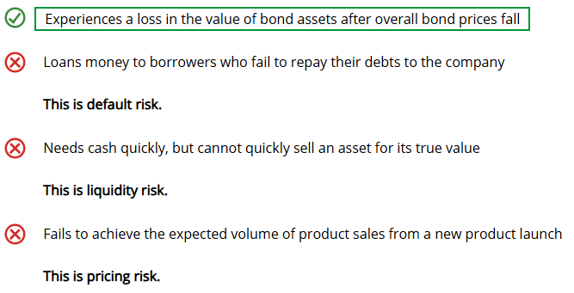

- One major category of operational risk is business process risk. The other category of operational risk is
- Event risk
- Default risk
- Competition risk
- Liquidity risk

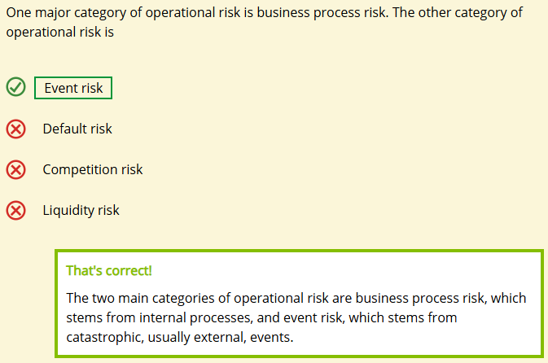

- From the following risks, select the examples of operational risk. Choose all that apply.
- Loss of company reputation
- Fraud
- Default risk
- Loss of a key employee
- Rating agency risk
- Risk from natural disasters

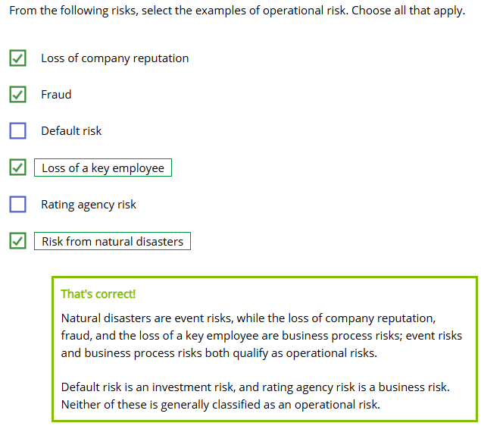

The Control Function
Learning Objective
Explain control and the control cycle.

The control function (Management activity directed toward ensuring that an organization's mission and objectives are accomplished effectively, efficiently, and according to plan.) is one of the four basic management functions—remember? Controls and control processes are also important tools for managing risks.
A company's efforts to manage risk depend strongly on the control function. The control function includes all the company's policies, procedures, and checks designed to ensure that the company sticks to its plans and accomplishes its objectives.
Categories and Phases of Control
Think of a business process, such as underwriting an application, issuing a contract, responding to a customer inquiry, handling a claim, or any other task you encounter in your work. All of these processes are subject to controls.
Process controls are divided into three general categories, each reflecting a phase of a business process that is subject to controls. Click or touch each one below to learn more.
Steering Controls
Steering controls ( are applied before a process. Examples include
- Policies (an equal employment opportunity policy)
- Operating procedures
- Performance standards
- A code of ethics or business conduct
- Budgets
- Schedules
- Goals and objectives
- Goal setting in an employee performance appraisal system
- Training
- An underwriting manual

Concurrent Controls
Concurrent controls are applied during a process. Examples include
- Activity logs or transaction logs that monitor company activities
- Error logs
- Pop-up error messages if out-of-range values are entered into a system
- Supervisory approval on claim checks exceeding a specified dollar amount
- Real-time monitoring of customer calls
- Elapsed-time clocks running during customer service calls
- A supervisor's approval signature on an expense report
- A requisition voucher for supplies
- Suspense account entries

Feedback Controls
Feedback controls (A control that takes the form of checks and corrections that are applied to a process at the end of the process cycle.) are applied after a process. Examples include
- Audits
- Account reconciliations
- Performance appraisals in a performance system
- Shareholder meetings
- Customer satisfaction surveys
- Budget analysis
- Actual-to-expected (A/E) analysis of expenses


Your support for controls is critical to your company's overall success. What's YOUR role in controls? Choose all that apply
- To understand controls related to your job
- To support controls through your job-related actions
- To encourage colleagues to respect controls
All is correct!
Each of these choices describes ways that employees support their company's controls.

The Control Cycle
"Those who cannot remember the past are condemned to repeat it." - George Santayana
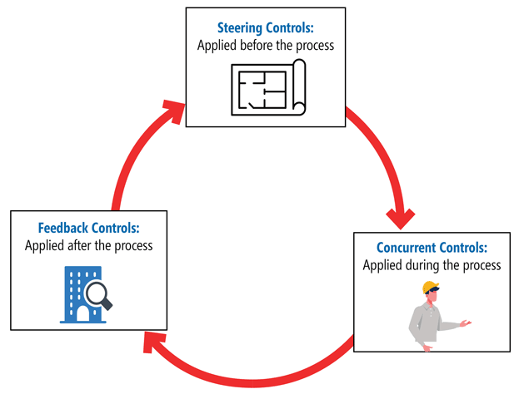
Insurers use the lessons of history to improve their operations and risk management. The three categories of controls are not a straight line, but a cycle: the control cycle.
The insurer uses feedback from its control activities to improve its business processes. That's probably not a surprise. But it also uses that feedback to improve the control activities themselves.

- An audit is an example of a [steering / feedback] control, which is used [during / after] a business process.
- steering / during
- feedback / during
- steering / after
- feedback / after
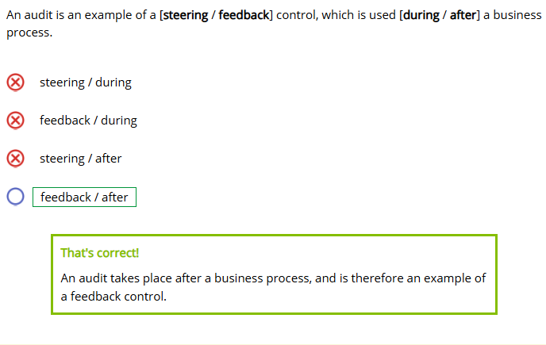

- Which of the following is an example of a steering control? Choose all that apply.
- Customer satisfaction surveys
- Elapsed-time clock in phone calls
- Goal setting
- Policies and procedures
- Employee training
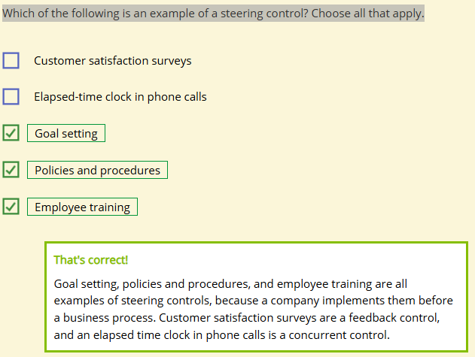

Addressing Risk
Learning Objectives
Describe techniques for managing risk, including risk transfer, diversification, and risk hedging.
Explain enterprise risk management in financial services companies.
The risk-return tradeoff means that an insurer can't earn sufficient return without accepting some risk.
However, even if a company can't avoid risk completely, it can still limit its exposure to risk. Risk may be inevitable, but risk management (A systematic application of management policies, procedures, and practices to identify, quantify, model, offset, and limit the impact of unexpected outcomes, consistent with organizational objectives.) is about controlling risk to some degree.
Risk Management
Financial services companies use many approaches to managing risk, including instituting and enforcing appropriate controls.
Let's talk about some others. First: transferring risk.
Risk Transfer
Forthright uses insurance and reinsurance to transfer risks to other parties.
How Forthright Uses Insurance and Reinsurance
Insurance:
- Life insurance on key employees
- Property and casualty insurance for company assets
- Liability insurance for key employees
Reinsurance:
- Reinsurance limits Forthright's potential claims expenses on insurance business
- Obtaining reinsurance gives Forthright access to outside expertise about risk management
Diversification
Another important risk management technique is diversification—spreading risks so that no one loss will take everything you have.

Here's a catchy folk saying: "Don't put all your eggs in one basket."
Forthright diversifies its
Investment risks by purchasing assets in a variety of asset classes, such as bonds, stocks, mortgages, and real estate
Pricing risks by issuing several types of products to people in a variety of risk classes, geographic areas, occupations, industries, and ages
Operational risks by maintaining several offices and storing backups of data in several places so that, in the event of an emergency, the company can continue operating
Dependence on third party reimbursements by placing insurance and reinsurance with a variety of carriers rather than just one company
Hedging Risks
Another way to manage risks involves balancing one risk with a complementary risk—called hedging. Click or touch the right arrows below to learn about hedging investment risks.

Hedging Investment Risk

Ideally, when one investment suffers negative outcomes from a risk, the other investment will experience positive outcomes from the same risk.
Click or touch the right arrows below to learn about hedging pricing risk.

Hedging Pricing Risk

To hedge pricing risk, an insurer sells another product that stands to gain when the first product is losing.

Reinsuring a portion of the risk of a block of policies is an example of the [transferring risk / hedging / diversification] risk management technique, while offering products with complementary risk profiles is an example of [diversification / hedging].
Enterprise Risk Management
How is ERM different from risk management without the "E"?
Enterprise risk management (ERM) takes an enterprise-wide view of risk management, looking at all the risks and opportunities, and taking a systematic, coordinated approach to managing them all.
ERM is usually directed from the top, with a
- Risk Committee of the Board of Directors that has ultimate oversight of ERM
- Chief Risk Officer (CRO) or Risk Management Director (RMD) who directs the company's ERM activities
Companies may have a team or even a formal department dedicated to ERM. Companies often employ risk analysts, who are generally trained actuaries.
Although ERM starts at the top, remember that it is an enterprise-wide practice. With ERM, every employee plays a role in managing risk. One way to achieve this goal is by establishing a risk culture.
Everyone should have an idea of how much risk the company is willing to accept, and be able to recognize potential new risks as they arise.
For example, Forthright has a fairly conservative risk culture. The investment team receives an offer to invest in a particular tech company. The investment seems to be both high-risk and offering high potential returns. This is more risk than Forthright's risk culture prefers, so the investment team declines the offer.
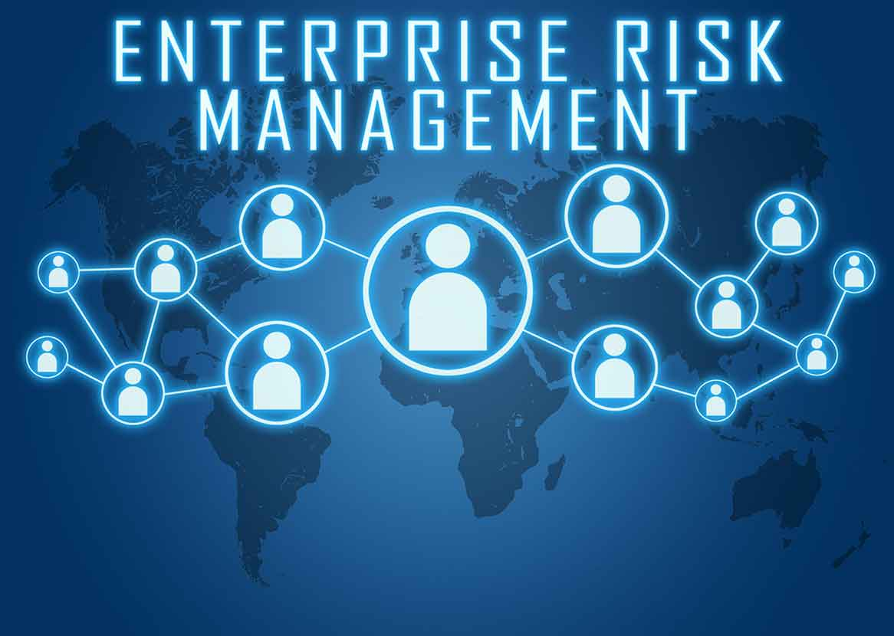
ERM involves reporting company risk information not just inside the company, but also to external stakeholders.
Regulators and rating agencies expect an insurer to have an ERM program. When evaluating a company, they review
- The quality and effectiveness of the company's ERM program
- The risks the company faces
- Its strategies for managing risks
You may think that ERM is all about guarding against threats, but it's not. It's also about taking opportunities. ERM helps insurers evaluate which opportunities to pursue. With a sound ERM program and sound ERM strategies in place, a company can understand each investment in terms of its potential earnings relative to its risk. The insurer can evaluate
- The risk of the investment
- The potential return of the investment
- Whether the potential return justifies taking the risk

The following statements pertain to enterprise risk management in a typical financial services company. Select each correct statement.

- ERM targets not only risks that threaten a company's viability but also those that have the potential to enhance profitability.
- ERM provides risk information to internal parties but not external stakeholders.
- Currently, rating agencies expect insurers to have an effective ERM program in place.
- Some companies have an ERM department.

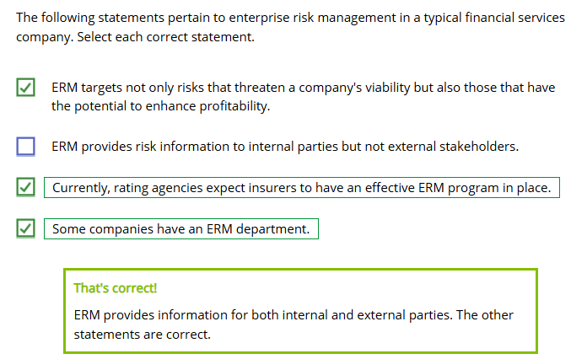

The Three Lines of Defense
Learning Objectives
Describe the three lines of defense, and explain how insurers use them to manage risk.
No single technique can manage every risk. That's the idea behind the three lines of defense risk management model.
Think of the three lines of defense as like barricades, or a ring of walls protecting a castle. If a risk slips past the one line of defense, the next line of defense is ready.
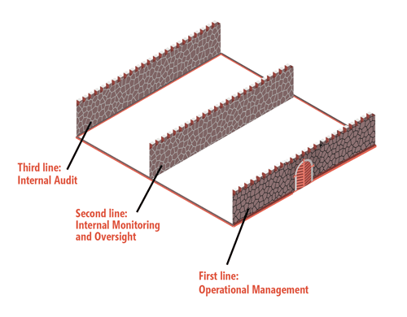
The three lines of defense overlap with other risk management frameworks.
Remember the organization-wide focus of ERM? The three lines of defense also has an organization-wide focus.
First Line: Operational Management
The first line of defense, or the frontline, is operational management.
Operational managers are responsible for identifying risks as they arise and taking appropriate steps to minimize the effect of those risks.
In turn, managers train employees to identify and manage risks appropriately. For example, all employees may receive training to deal with potential cybersecurity risks such as viruses, but underwriters may receive specific training to recognize the signs of a potentially fraudulent application.

The first line of defense is a real team effort: we're all on the frontline together.
Second Line: Internal Monitoring and Oversight
The second line of defense—internal monitoring and oversight—looks for signs of risks that might not be obvious on the frontlines.
A company's risk committee and compliance function are both key players in the second line of defense.
Internal monitoring double-checks risk management to make sure things are going well.
The oversight function owns aspects of the risk management process and helps set risk policy. For example, the risk committee may develop policies for data backups and restoration of email function in the event of a catastrophic event striking the home office.

Think of the second line of defense as risk specialists. Risk is our business.
Third Line: Internal Audit
The third line of defense, the internal audit, determines if the first two lines of defense have been performing to expectations.
Internal audits systematically examine the company's risk management to determine what is working and what could be improved.
Internal audits are different from the other two lines of defense in two important ways:
- Objectivity. An audit measures facts and evidence only. It doesn't weigh risk against potential reward—it only reports results.
- Organizational independence. An auditor reports only to the highest level of management. This helps keep the audit unbiased.

The third line of defense gives us the facts we need to be sure that risk management is working as intended.

In the three lines of defense risk management model, a product line manager and her employees are on the
- First line of defense
- Second line of defense
- Third line of defense
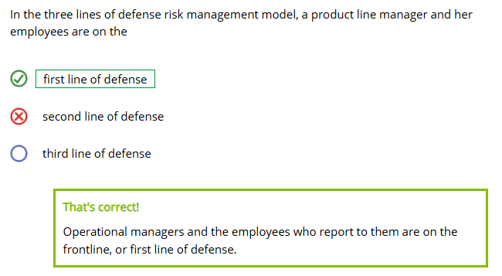
In the three lines of defense risk management model, members of a company's risk committee are on the
- First line of defense
- Second line of defense
- Third line of defense
